**PHASE 5:NOISE POLLUTION**

a real-time noise level monitoring system involves several components: IoT sensor deployment, a noise pollution information platform, and a mobile app for users. This system aims to promote public awareness of noise pollution and contribute to its mitigation. Below is an overview of each aspect, including diagrams and explanations:

**Project Objectives:**

1. **Real-time Noise Monitoring:** The primary objective is to monitor noise levels in real-time across different areas to provide accurate and up-to-date noise pollution data.
2. **Public Awareness:** The project intends to raise awareness among the public about noise pollution's effects on health and well-being.
3. **Data Collection:** Collect extensive noise data to identify noise pollution hotspots and understand its patterns.
4. **Noise Mitigation:** By making the noise data available to the public, authorities, and policymakers, the project aims to contribute to noise pollution mitigation strategies.

**IoT Sensor Deployment:**

Deploy IoT sensors across various locations within the target area. These sensors consist of:

* **Microphone:** A microphone captures ambient sound, which is then processed to determine noise levels.
* **Processor:** A microcontroller or processor is used to process audio data and calculate noise levels.
* **Connectivity:** Sensors are connected to the internet via Wi-Fi, cellular, or other suitable communication methods.
* **Power Supply:** Sensors are equipped with power sources, which could be batteries or wired power connections.
* **Location Tagging:** Each sensor is geotagged for accurate location-based data.

**Platform Development:**

The Noise Pollution Information Platform is a web-based application for noise data collection, analysis, and visualization. It includes:

* **Data Aggregation:** It collects data from all deployed sensors in real-time.
* **Data Analysis:** It processes and analyzes the data to determine noise pollution levels.
* **User Access:** Authorities, researchers, and the public can access the platform for noise information.
* **Data Visualization:** The platform provides graphical representations of noise levels, including heatmaps and time-series graphs.
* **Alert System:** It can send alerts when noise levels exceed a certain threshold.

**Mobile App Development:**

The mobile app provides a user-friendly interface for the public to access noise pollution data. Key features include:

* **Real-time Data:** Users can view the current noise levels in their area.
* **Historical Data:** Access to historical noise data for trend analysis.
* **Map Integration:** A map displaying noise levels in different locations.
* **Alerts:** Users can set noise level alerts for specific areas.
* **Feedback:** A feature to report noise disturbances.

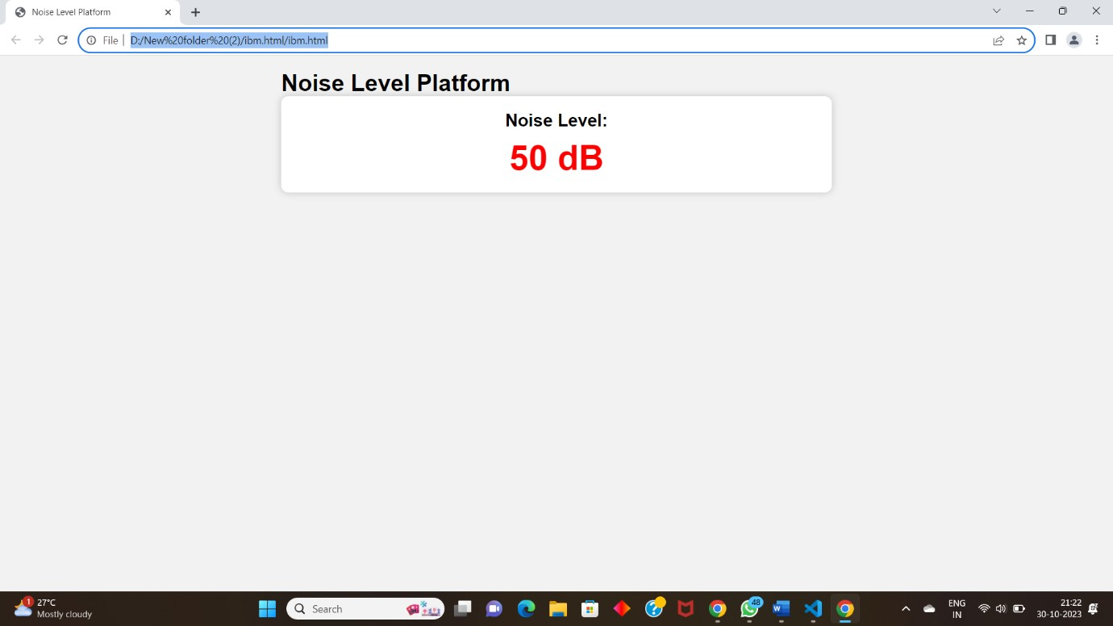

**Code Implementation:**

The sensors are programmed to capture audio, process it, and send the noise level data to the platform. The platform and mobile app are built using programming languages and technologies suitable for web and mobile development, such as Python, JavaScript, and relevant frameworks.

**Promoting Public Awareness and Noise Pollution Mitigation:**

The real-time noise level monitoring system promotes public awareness and contributes to noise pollution mitigation in several ways:

1. **Data Access:** By providing real-time and historical data, the system educates the public about the noise pollution levels in their area.
2. **Accountability:** Users can report noise disturbances, holding individuals or organizations responsible for excessive noise.
3. **Policy Support:** Authorities can use the data to implement noise regulations and enforce them more effectively.
4. **Urban Planning:** The system helps in making informed decisions about urban development and zoning to reduce noise pollution.
5. **Public Participation:** Increased awareness and access to data encourage the public to participate in noise reduction efforts.

The combination of IoT sensors, a noise pollution information platform, and a mobile app creates a comprehensive system that empowers individuals and authorities to take actions to reduce noise pollution, ultimately leading to healthier and more peaceful communities.

